PROVISIONAL MARKING KEY
CHEMISTRY II
- Describe an experiment that could be carried out to prepare nitric acid in
the laboratory.

Procedure:
- Set up ^{(1 mark)} the apparatus where a retort flask is connected ^{(1 mark)} to round bottomed flask.
- Put ^{(1 mark)} 25g of potassium nitrate, KNO_{3(s)} in the retort flask ^{(1 mark)}.
- Add ^{(1 mark)} 30cm³ of concentrated sulphuric acid to cover ^{(1 mark)} the potassium nitrate in the retort flask.
- Run ^{(1 mark)} the tap water to the round-bottomed flask to condense ^{(1 mark)} the acid vapour produced.
- Heat ^{(1 mark)} the retort flask gently.
- Observe ^{(1 mark)} the colour of the liquid acid produced in round-bottomed flask.
(Total 10 marks)
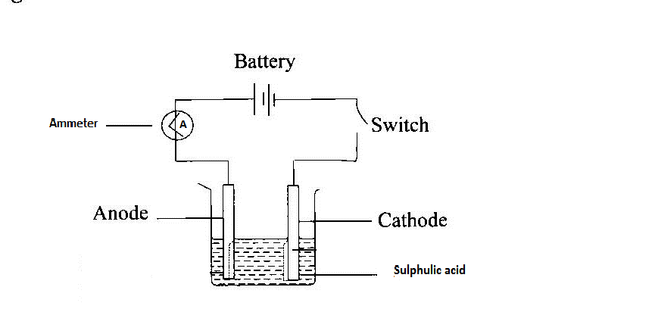
(Amounts of different substances can be any, provided they are matching with laboratory activities).

- 1 mark for correct diagram
- 1 mark for correct label
- ions present in the solution are H⁺ and ${SO}_{4}^{2-}$ from sulphuric acid and
H⁺ and OH⁻ from water. (1 mark)
- Both ${SO}_{4}^{2-}$ and OH⁻ move to the anode to discharge (lose the charge) but it is OH⁻ that discharges in preference to ${SO}_{4}^{2-}$ (1 mark) forming 2 molecules of water, one molecule of oxygen and 4 electrons according to the equation:

$4OH_{(aq)}^{-}$ → 2H₂O(l) + O₂(g) + 4e⁻ (1 mark)
- Oxygen gas produced is liberated at the anode while the 4 electrons move (1 mark) to the cathode via external circuit.
- H⁺ move to the cathode to discharge by 4 electrons producing hydrogen gas (1 mark) according to the equation:

$4H_{(aq)}^{+}$ + 4e⁻ → ${2H}_{2(g)}$ (1 mark)

- Hydrogen gas produced is liberated at the cathode. (1 mark)
- Therefore, it can be said that electrolysis of dilute sulphuric acid is simply electrolysis of water since $H_{2(g)}$ and O₂(g) are produced at the electrodes in the ratio of 2:1 similar to chemical composition of the water molecule. (1 mark)

Liquid in test tube | Initial Temperature(℃) | Substance added | Final Temperature(℃) | Temperature change (℃)
Water |  | Sodium hydroxide
water |  | Ammonium nitrate
Any suitable / applicable temperature change
1 mark for both initial temperatures
1 for each final temperature
(5 marks)
Exothermic reaction: dissolving of sodium hydroxide 1
Endothermic reaction: dissolving of ammonium nitrate 1

i.

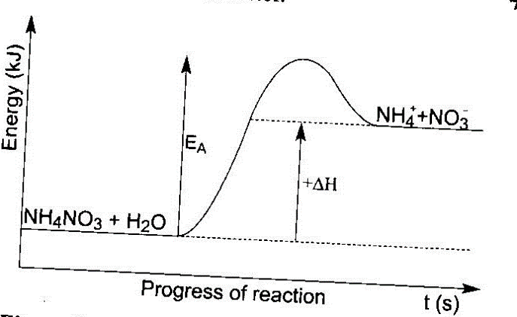
1 mark

1 mark
- Part of activation energy is optional
- 1 mark for arrow or positive ∆H
- 1 mark for labelled axis
- 1 mark for correct position of reactants and products

- Initial volume: 0ml
Final volume: 10ml 2
Volume used: 10ml 2
$2NaOH\left(aq\right)+ H_{2 }$SO_{4(l)} → ${Na}_{2}$SO₄$\left(aq\right)$ + 2H₂O(l) 1 equation
1 balancing
$\frac{Concentration ×volume}{no. of moles}$ (acid) = $\frac{Concentration ×volume}{no. of moles}$ (base)
$\frac{concentration ×10ml}{1 mole}$ = $\frac{0.1M ×10ml}{2 moles}$ (acid) 1 substitution
Concentration = $\frac{0.1 M ×10ml ×1 mole }{10 ml × 2 moles}$ 1 simplification

Concentration = 0.05 M 1 answer
End of marking key

